Patient Intake Form
Personal Information
Name: ___________________________________________ Date of Birth: _________________ Gender: M F
Home Phone: ________________________ Cell Phone: _________________________ Work Phone:________________________
Email: _________________________________________ SSN#:_____________________ Name of spouse: ___________________
Address: ____________________________________City: __________________________State: ________Zip Code:____________
Employer: __________________________________Physical work duties: ______________________________________________
Emergency Contact: _____________________________ Relationship: ___________________ Phone: _______________________
Insurance provider: ________________________ ID#: ____________________________ Group #: _______________________
Name of insured if different from patient: ________________________ Relationship: _________________ DOB: _____________
Here today for: Wellness Complaint Injury Work Comp Auto Accident Other:_____________________
Complaint/Condition: ___________________________________________ How long has this been an issue? _______________
Does this condition: Interfere with daily activities? Yes No Affect quality of sleep or ability of sleep? Yes No
Affect your appetite? Yes No Cause you to miss work? Yes No
What makes it better? ___________________________________ What makes it worse? ___________________________________
Have you seen a health care provider for this condition? Yes No Name of Provider: ________________________________
Describe Your Symptoms
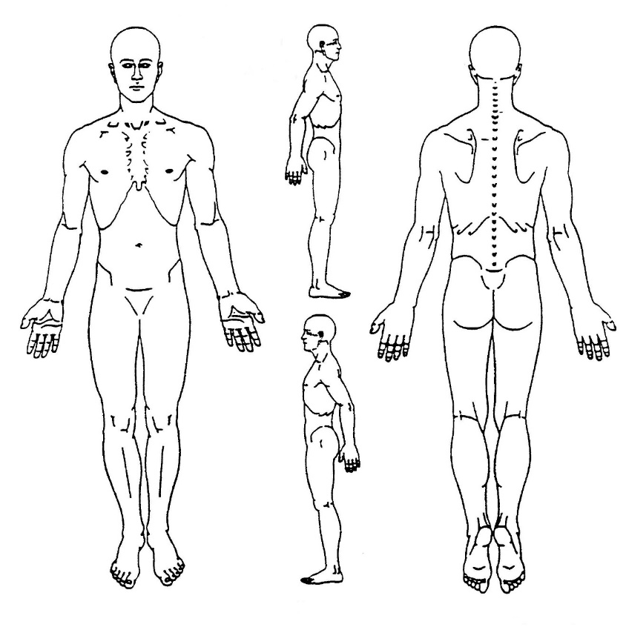

A = Aching
B = Burning
R = Radiating
D = Dull Pain
N = Numbness
S = Stabbing
T = Tingling
O = Other

Intensity of symptoms: None 0 1 2 3 4 5 6 7 8 9 10 Unbearable

Frequency of symptoms: Continuous Intermittent Occasional Frequent

Personal Health History
Primary Physician:_____________________________________ Pregnant? Yes No
Health conditions treated in the last year: _________________________________________________________________________
Medications/Supplements: _____________________________________________________________________________________
Please list any significant family health history: _____________________________________________________________________ ________________________________________________________________________________________________________________________________________________________________________________________________________________________
Health Problems/Concerns
Allergies Alcoholism Anemia Arthritis Asthma Back Pain Autoimmune Disease Bleeding DisorderBreast Lump Bronchitis Bruise Easily Cancer Chest Pain Digestion Problems Hot Flashes Cold Extremities Depression Diabetes CVA/Stroke/TIA Epilepsy Irregular Menstrual Cycle Dizziness Loss of Memory Fatigue Hemorrhoids Thyroid ConditionKidney Stones Shortness of Breath Headache Kidney Infection Tuberculosis Nosebleeds Venereal Disease Sleep Problems Irregular Heart Beat Migraines Loss of Smell Varicose Veins Loss of Balance Seizures Liver Disease Eye Pain/Difficulties Loss of Taste Lung Disease Pacemaker Parkinson’s Sciatica Spinal CurvaturesFrequent Urination Ulcers Gout Acid Reflux/IBS Skin Sensitivity Swollen Joints Dementia Gallbladder Disease Alzheimer’s Cramps High/Low BP Congestive Heart Disease Diagnosed Emotional/Mental Disorder
Cardio Vascular Disease: ______________________________Other ______________________________
Personal Incident History
Auto collision?_________________________________________________ Treatment?__________________________________
Work injuries?_________________________________________________ Treatment?__________________________________
Broken Bones?_________________________________________________ Treatment?__________________________________
Sprains/Strains?________________________________________________ Treatment?__________________________________
Surgeries/Hospitalizations?___________________________________________________________________________________
Chiropractic Experience
How did you hear about our office?
Internet Community Event Sign Mailing Newspaper Yellow Pages
Referral: ___________________________ Other: ___________________________
Previous chiropractic care? Yes No Condition(s) treated: ___________________________ Date of last visit: ___________
Authorization
I certify that I am the patient (or legal guardian of the patient) listed above. I have read/understand the included information and certify it to be true and accurate to the best of my knowledge. I consent to the collection and use of the above information to this office of chiropractic. I hereby authorize the doctor to release all information necessary to any insurance company, attorney, or adjuster for the purpose of claim reimbursement of charges incurred by me. I grant the use of my signed statement of authorization with my signature for required insurance submissions. I understand and agree that all services rendered to me will be charged to me, and I’m responsible for timely payment of such services. I understand and agree that health/accident insurance policies are an arrangement between an insurance carrier and myself. I understand that fees for professional services will become immediately due upon suspension or termination of my care or treatment.
Name: ____________________________________________
Signature: _________________________________________ Date: ____________________

Informed Consent
I hereby authorize physicians and staff at Crow Wing Chiropractic to treat my condition as deemed appropriate. The doctor will not be held responsible for any pre-existing medical conditions.
I certify that the above information is correct to the best of my knowledge. I will not hold my doctor or any staff member of Crow Wing Chiropractic responsible for any errors or omissions that I may have made in the completion of this form.
Chiropractic, as well as all other types of health care, is associated with potential risks related to your care to allow you to be fully informed before consenting to treatment.
Chiropractic is a system of health care deliver and therefore, as with any health care delivery system, we cannot promise a cure for any symptom, condition or disease as a result of treatment in this office. An attempt to provide you with the very best care is our goal, and if the result are not acceptable, we will refer you to another provider who we feel can further assist you.
Specific Risk Possibilities Associated with Chiropractic Care:
Soreness – Chiropractic adjustments and physical therapy procedures are sometimes accompanied by post treatment soreness. This is a normal and acceptable accompanying response to chiropractic care and physical therapy. While is in not generally dangerous, please advise your doctor if you experience soreness or discomfort.
Soft Tissue Injury – Occasionally chiropractic treatment may aggravate a disc injury, or cause other minor joint ligament, tendon, or other soft-tissue injury.
Rib Injury – Manual adjustments to the thoracic spine, in rare cases, may cause rib injury or fracture. Precautions such as pre-adjustment x-rays are taken for cases considered at risk. Treatment is preformed carefully to minimize such risk.
Stroke – Stroke is the most serious complication of chiropractic treatment. The most recent studies estimate that the incidence of this type of stroke is 1 in every 5 million upper cervical adjustments.
Other Problems – There are occasionally other types of side effects associated with chiropractic care. White these are rare, they should be reported to your doctor promptly.
If you have any question concerning this form or the above statements, please ask your doctor.
Having carefully read the above, I hereby give my informed consent to have chiropractic treatment administered.
Patient/legal guardian Signature: __________________________________________________ Date: _____________________
Name/relationship to patient: ____________________________________________________

